Task - 17 Output :

1.

1.Opening the chrome browser

2.Navigates to<http://www.demoblaze.com/>

3.Maximised the browser window.

4. In categories Founded laptop.

5. And clicked on sony vaio i5.

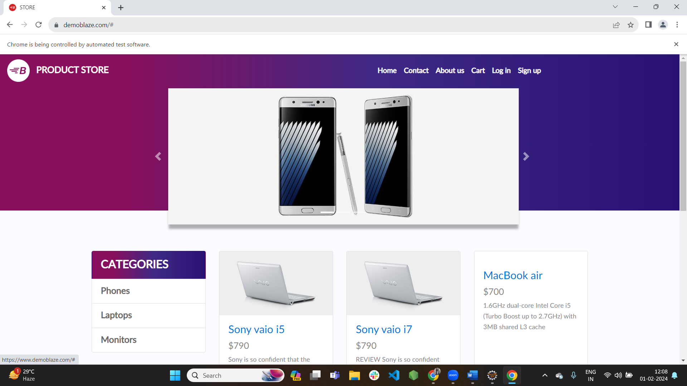

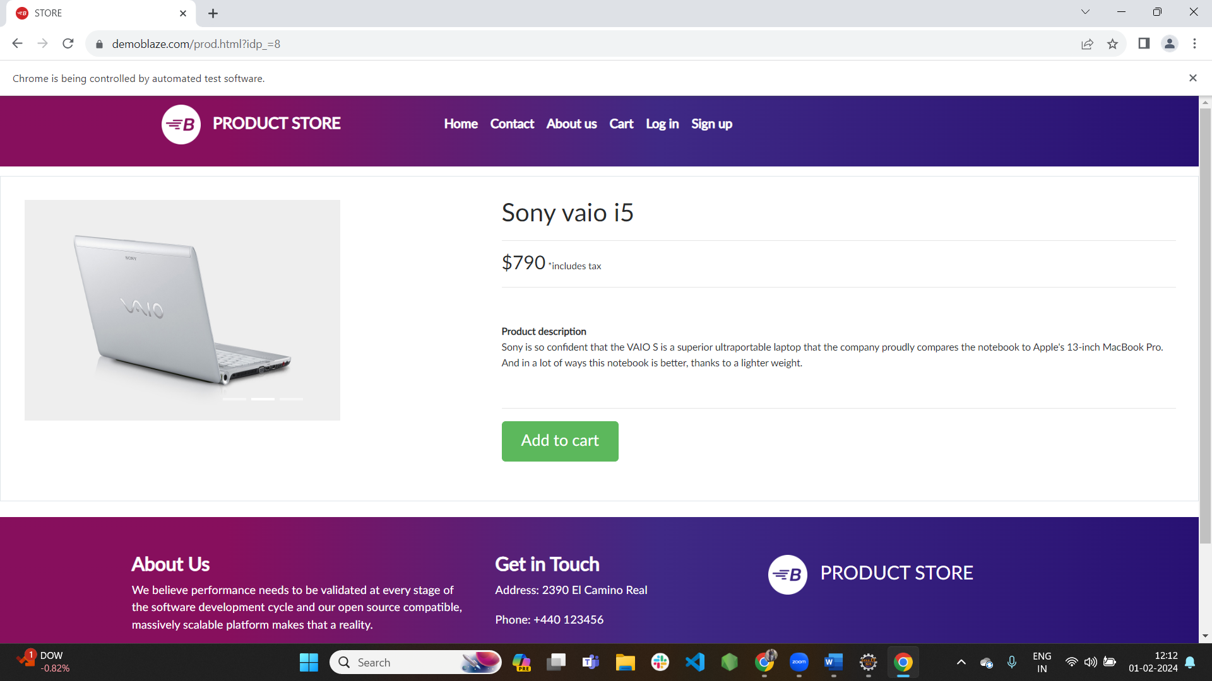

6. The item is added to the cart.

